1C - Financial – Lesson 4
Taxation – Refund or Tax Debt

Name: _________________

- What do we mean by taxable income?

- What is a TFN?

- What is the Medicare levy?

- What is the Medicare surcharge?

- Bill earns a taxable income of $95,000.

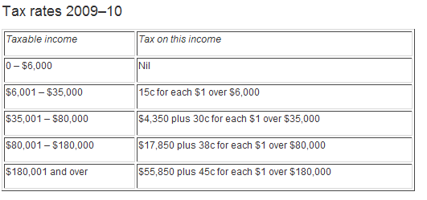

  - How much tax does he have to pay? [See the last lesson for more detail]

Tax = $ _______ + $ __ x ($ ________ - $ ________ )

  - What is their Medicare levy? (1.5%)

Levy = ___ x $ _________ = $ _________

  - What is their Medicare surcharge? (1%)

Surcharge = ___ x $ _________ = $ ________

Calculating tax payable.
Taxable Income

Tax Calculation
Tax on taxable income
Medicare levy
Medicare levy surcharge
Financial supplement payment
HELP Repayment
Sub-total: Gross tax payable
Tax withheld – salary and wages type income
Tax withheld – voluntary agreement
Tax withheld – where ABN not quoted
Tax withheld – labour hire or other specified payment
Tax withheld – where TFN not quoted
Franking credits
Australian franking credits from a New Zealand company
Foreign resident withholding credits
Share of credit for tax paid by trustee
Tax offset used
Early payment interest credit
Sub-total: Total tax offsets and credits subtracted
Estimated tax payable

  - Place the taxable income, tax on taxable income, Medicare Levy and Medicare surcharge in the left column.

  - Add the taxable income, Medicare Levy and Medicare surcharge to find the Gross tax payable and put it in the middle column.

  - Put a Tax offset used [dependant spouse allowance] of $2100 in left column.

  - Also put an early payment interest credit of $100 in left column.

  - Add the Tax offset used and early payment interest credit to find the total offsets and credits subtracted and put it in the middle column.

  - Subtract the total offsets and credits subtracted from the Gross tax payable to find the estimated tax payable and put it in the right column.

  - What is the difference between a tax refund and a tax debt?

  - If Bill made $5000 in tax installments then calculate his tax refund.

